OOP Assessment Stage 11

Create the following JFrame form-

Edit Product (Clothing Selected) – Accessed via Staff Product Menu page (page which allows staff to select a Product and edit/delete products)
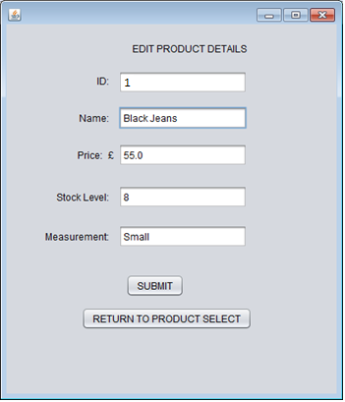

Edit Product (Footwear Selected) – Accessed via Staff Product Menu page
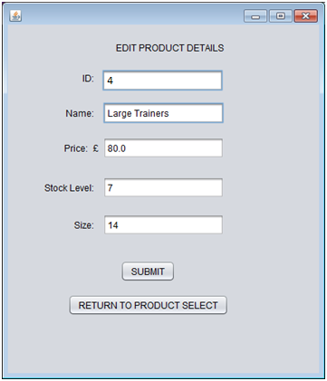

This should be done using 1 JFrame with 'Measurement' appearing if you have selected a Clothing and 'Size' appearing should you have selected a Footwear.

All details should be loaded onto the form once you select a Product from the Staff Product Menu.

Create the DBManager method now to edit a Clothing/Footwear. This method should have 1 input parameter- a Product.

Once implemented fully- test by modifying both a Clothing AND Footwear product and ensure that you are updating ALL the correct columns for these products inside your database.

Additional Task (optional):
- Add error detection in case the user leaves any text field blank
- Add error detection for checking that price, stock level and size are all valid integers or doubles.
- Try and disable the Product ID text field so the user cannot modify it’s value

